**Prerequisite:**

Maven needs to be downloaded and installed from <https://maven.apache.org/download.cgi>

Set the Environment variables for Maven

Go to Jenkin dashboard - manage Jenkins

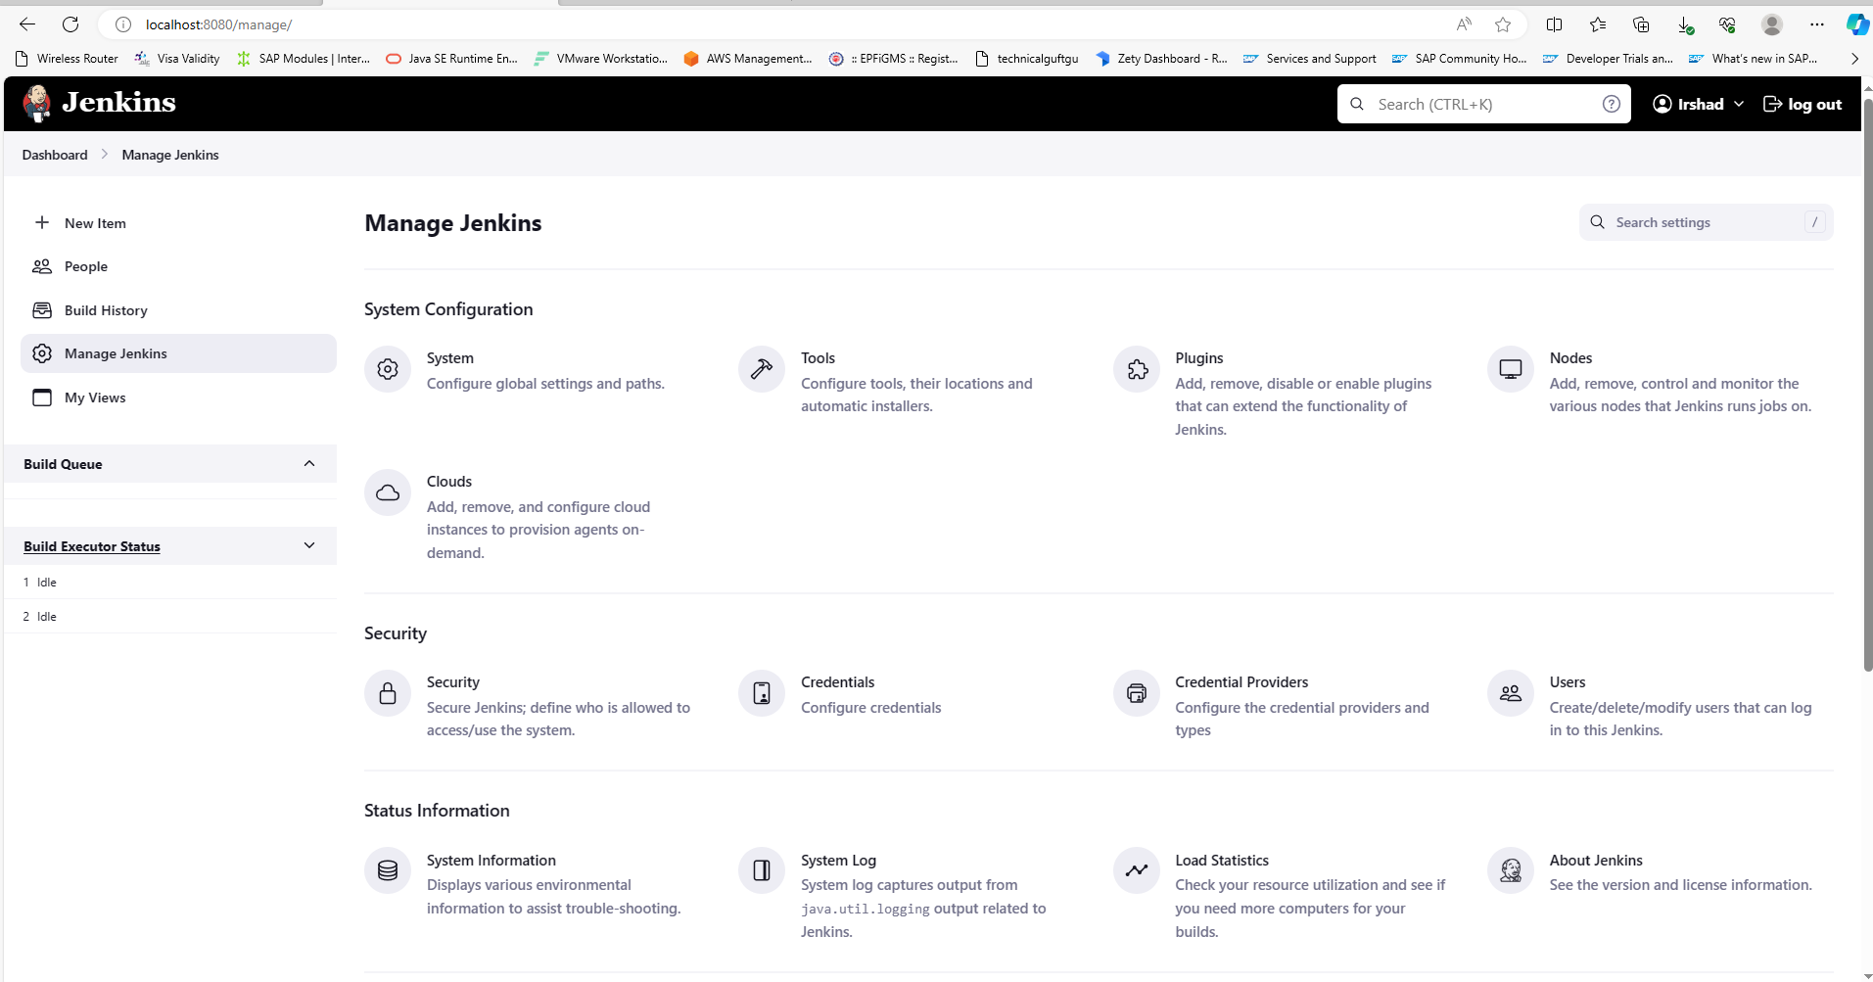

Click on plugin – select available plugin

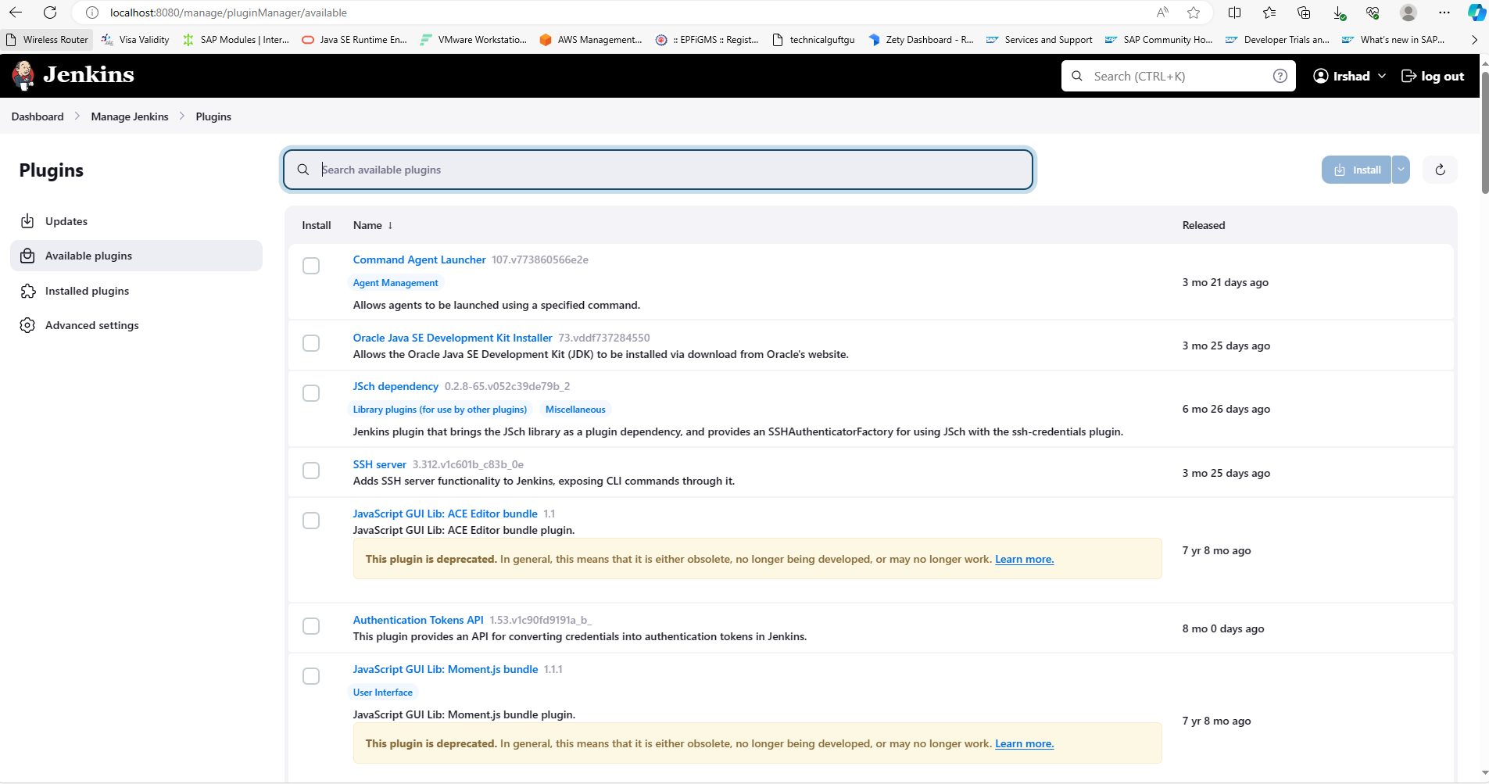

Search Maven plugin plugin and click on install

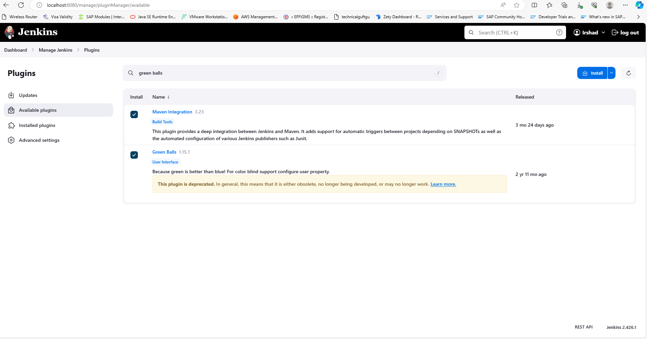

Maven integration plugin installed successfully

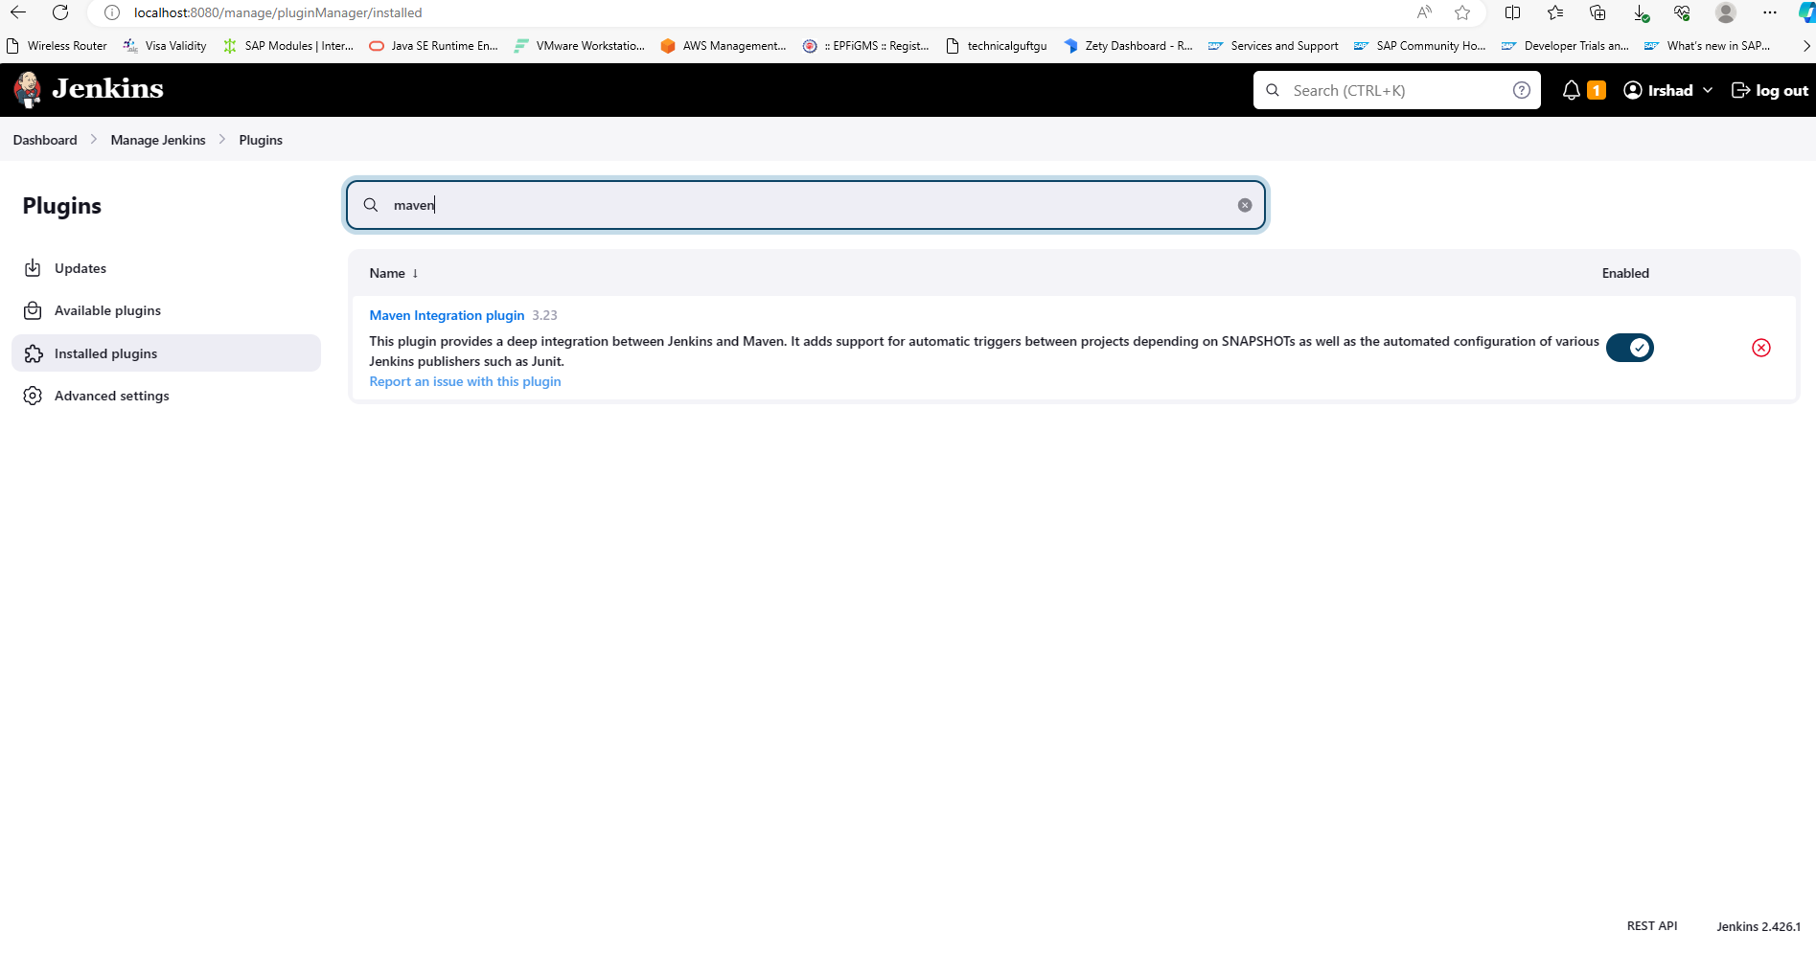

Now we can see maven plugin is available and ready to use

Go to Manage Jenkins – Tools – provide Java and Mavens paths available in local machine.

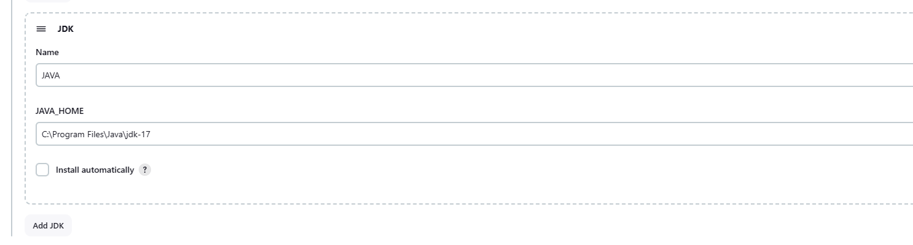

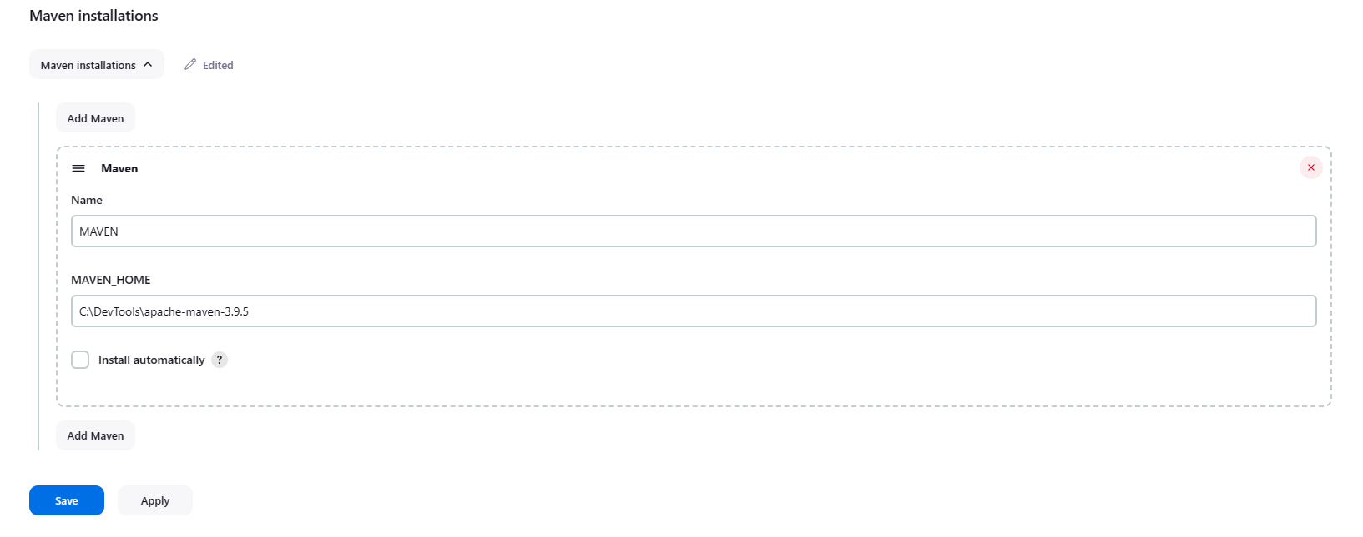

Click on apply and save

Fork the dummy project to your Git hub account

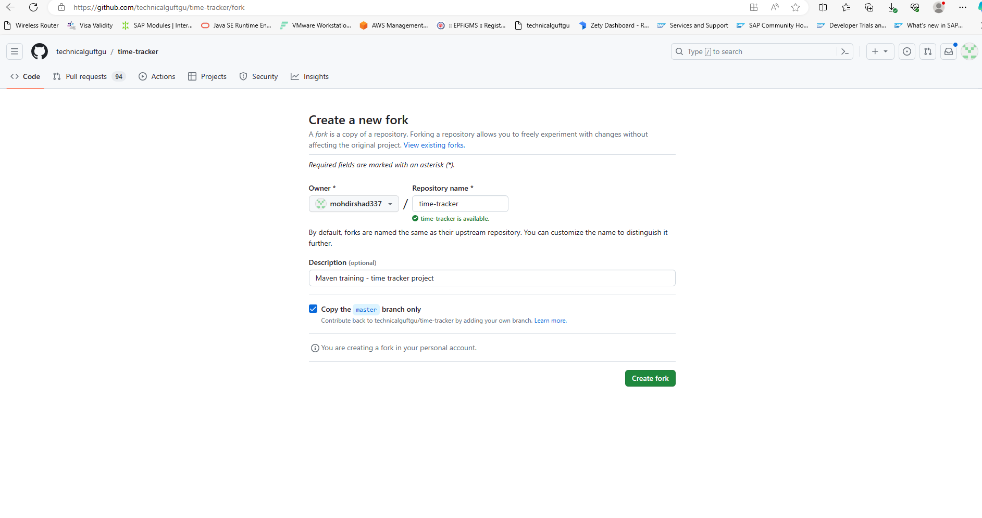

Now we can see project has been copied to our Git hub account

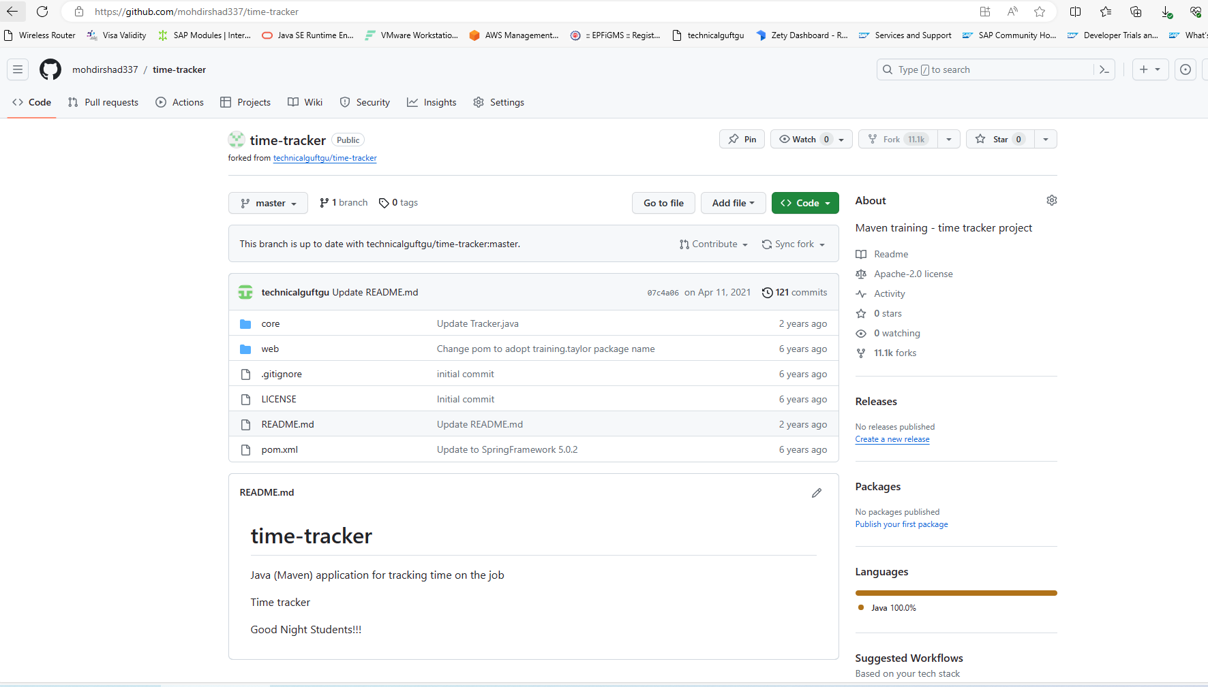

Go to Jenkins home page and select maven project

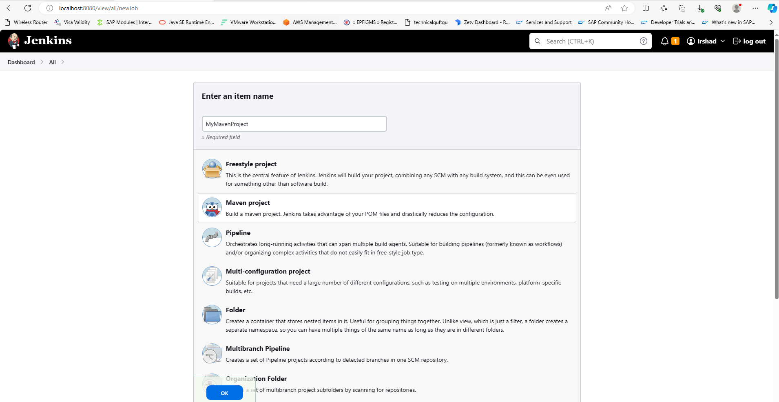

Select source code management and provide Git URl

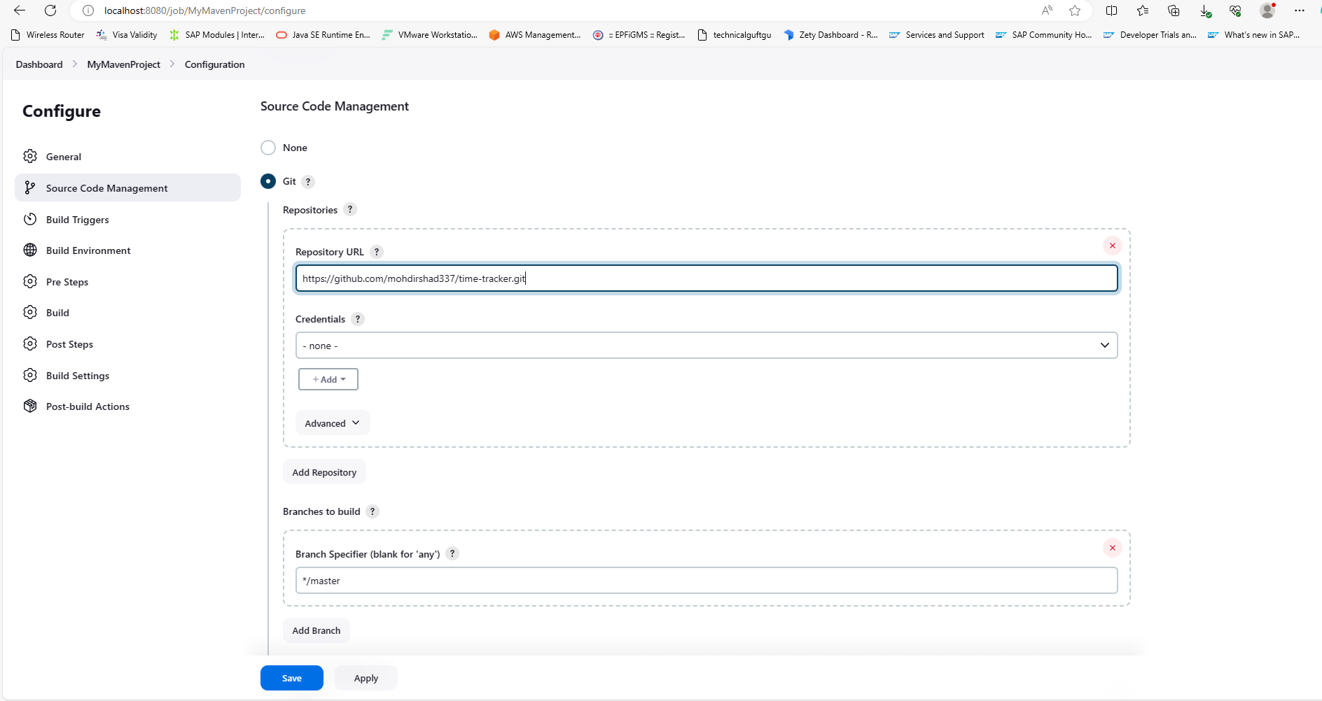

Now to Build tab -Goals and options – write – clean package (to build the code) and click on save

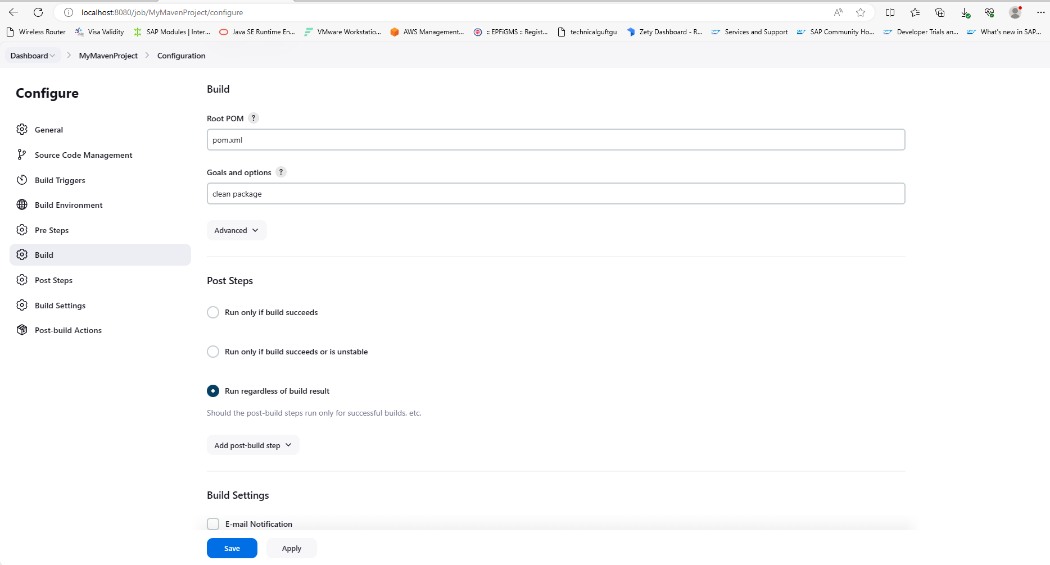

Now go to dashboard - select maven project and click on build now

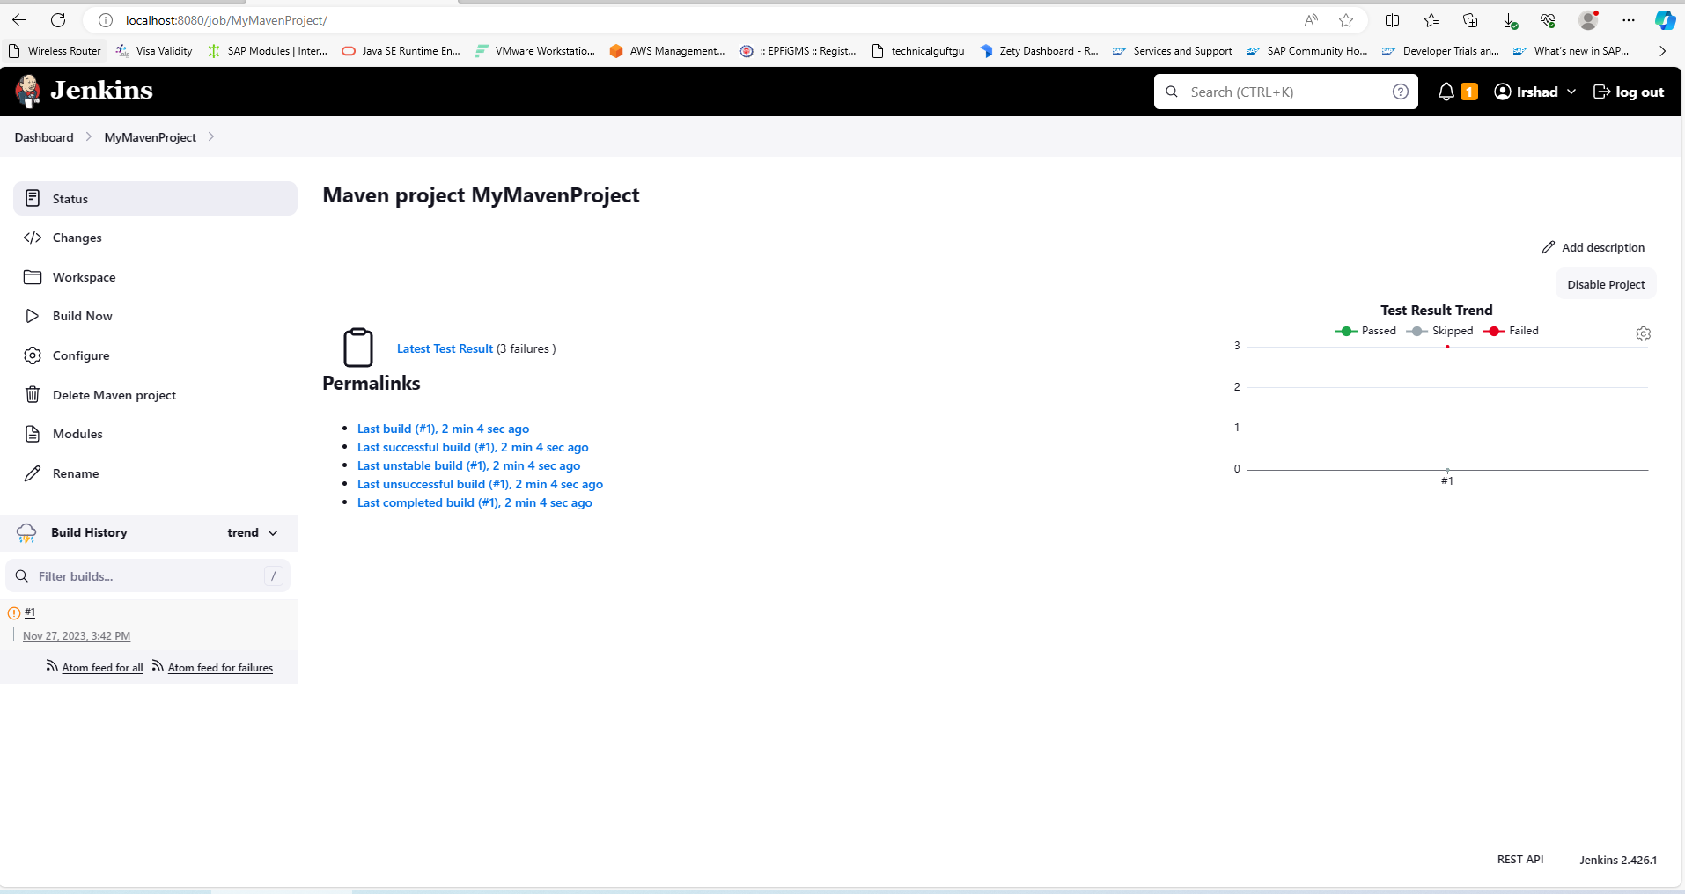

We can see code has build

To automate building the code select the project and click on configure

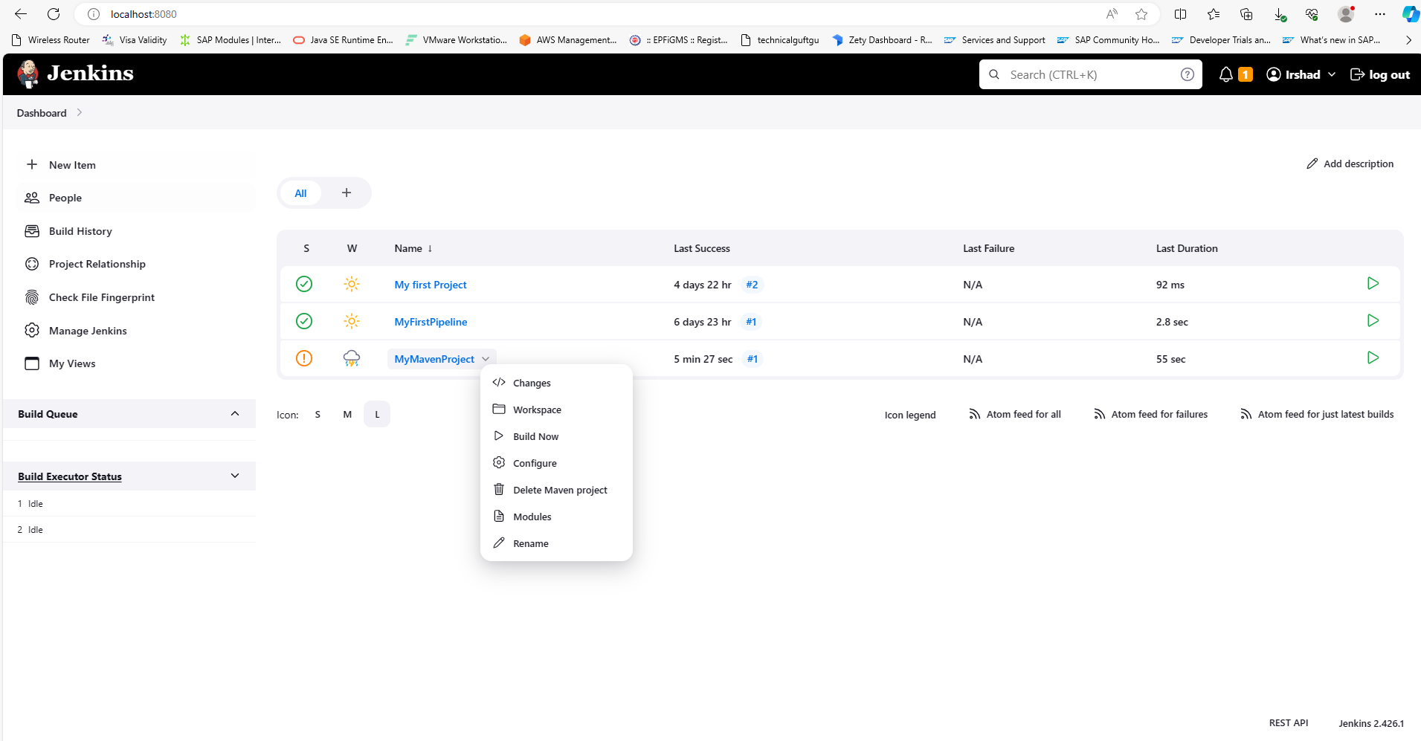

Go to build triggers and select Poll SCM and provide (* * * * *)- click on save

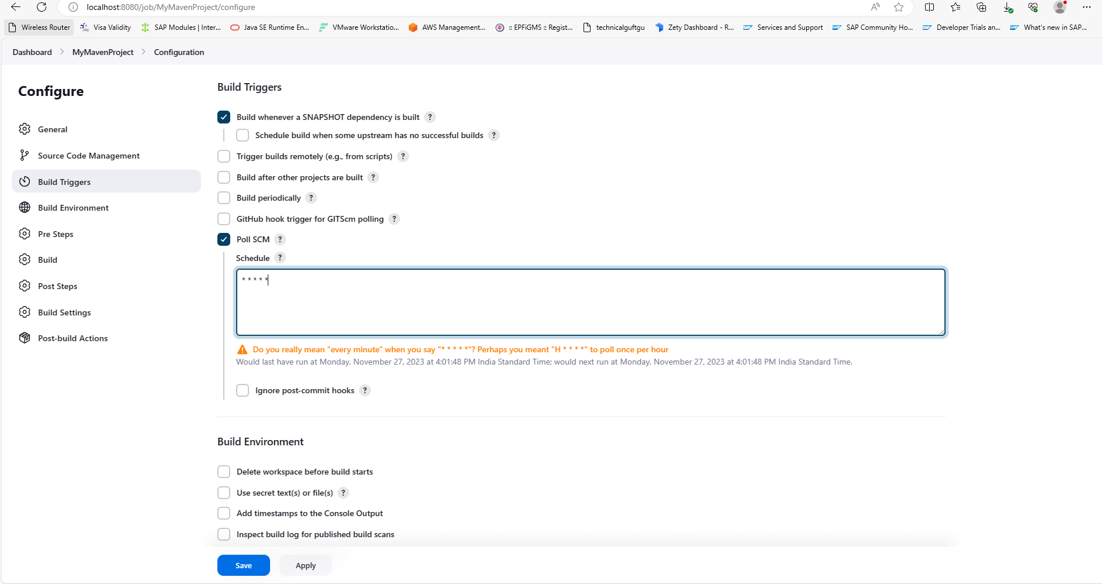

Go to repository and change the code to check whether the code will build automatically or not.

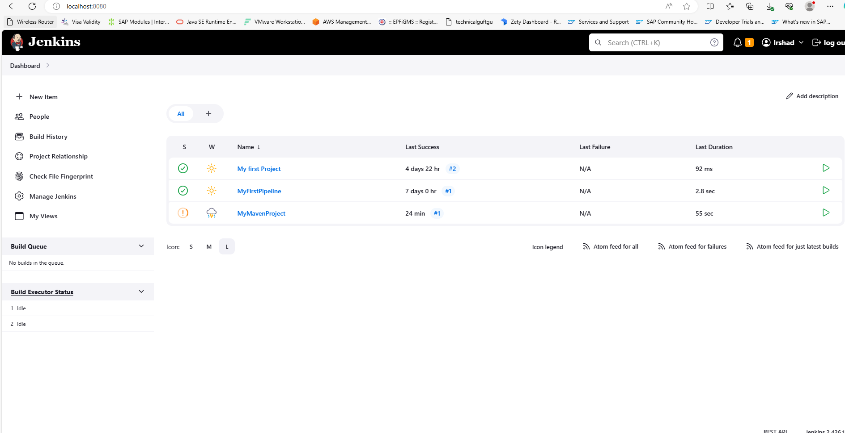

We can see above the code starts building after 1 minute.

